Houston Pipeline Company
I.T. Services
Transiton Summary

This document summarizes the I.T. Services to be provided by Enron to HPL before and after the close to HPL.

Prior to June 1st.
Summary: HPL employees will move into the 15th floor of 1201 Lousiana on two separate dates. Most of the HPL employees will move on April 20th except for Trading, Scheduling and Gas Control. Trading, Scheduling and Gas Control will move on May 5th. After the move and until Saturday June 2nd, these employees will continue to access Enron’s I.T. network for the applications and market data they have always used. This includes all of the Microsoft Office applications as well as e-mail. The current phone numbers used in the Enron Building will be forwarded to the phone system and the phones at 1201 Louisiana.

Global Data: New Counterparty ID’s will be created for the AEP version of HPL and the AEP Marketing entity. These should be released into production on April 16th. New portfolio ID’s and book codes are also in process of being set up. After this set up deal entry into Sitara can begin. A web based Counterparty set up form has been created for AEP. They will also have inquiry access to AEP’s Counterparty information via the web based Counterparty system. Separate security or maintenance groups are being created for both Global Contracts and Facilities. New AEP versions of the contracts will be created prior to the end of April. Enron’s version of these contracts will be terminated on the last day of May.

Deal Entry: New AEP versions of the 3rd party deals will need to be created effective with June production. Enron’s version of these deals will be terminated on the last day of May. Since Enron’s version of the HPL deals contains internal book codes and swaps the 3rd party deals will need to be rekeyed by the HPL employees. If AEP elects to key deals directy into ZaiNet and Sitara then they will need to key in the AEP ZaiNet deal number into the External Exchange Deal ID Field within Sitara’s Deal Manager. This will help create the deal number crossreference between AEP’s and Enron’s applications. This crossreference will occur automatically once the interface between AEP’s Trade Blotter and Sitara is in place.

Risk reporting: Prior to 6-1-01. HPL will continue to use ERMS to value their positions. A separate ERMS and CPR environment will be created for AEP/HPL processing effective with June production.

Security: The security for the HPL employees is currently being reviewed. For the most part everyones access will remain the same until close. At close access will be changed to remove access to ENA and Enron’s version of HPL for trades & contracts prior to 6-1-01 and these employees will then only have access to the AEP version of HPL’s deals and contracts.

After June 1st
Summary: It is currently anticipated that AEP’s space on the 11th and 12th floors may not be ready to move into on June 1st. It is anticipated that their data center on the 12th floor will be up and running by June 1st. If this occurs then the HPL employees will stay on the 15th floor and will move down into the AEP space during the month of June as the buildout is completed. We will cut over the 15th floor to AEP’s network on the weekend of June 2nd & 3rd. At that time the direct connection to Enron will be dropped. HPL employees will no longer have access to Enron’s network for email, Microsoft Office, Market Data and other Enron network provided applications. AEP will now be providing these applications and services via their data center. Enron will be providing access to the applications listed in the I.T. Services agreement via terminal server access. The applications to be provided by Enron via terminal server include, Sitara, ERMS, CPR, Global Contracts, Global Facilities, Global Counterparty, Unify, SCADA, DCAF II, MIPS/PGAS, TARP, IRIS and Right of Way. Data services will be provided via Phoenix, Global Common Codes and the EDI Hub. Please see Schedule A for a high-level systems data flow diagram. Schedule B includes a high-level process flow diagram. All data traffic between Enron’s and AEP’s networks will occur through T1 lines purchased by AEP and connected to Enron at its Ardmore data center.

Miscellaneous transitional services: Enron will provide the following services to aid the move from Enron services to AEP services:
- Phones - The old Enron number and phonemail will remain active for thirty days after Close. During this period HPL employees should update their phonemail message with their new AEP phone number. Phonemail access will be turned off on June 30th and the old numbers will be available to be reassigned after that date.
- Email - On or before June 2nd, HPL employees will receive a new AEP email address. Emails received by Enron at the old address "Jane.Doe@enron.com" will generate an automatic reply with instructions as to how to contact the HPL employee at AEP. This message will continue for two weeks after the close or until June 16th. After that date the Enron mail ID will be turned off.

Global Data: The following HPL Counterparty ID’s will be used Enron to continue to process PMA’s and business for production months prior to June 2001. Only Enron designated personnel will have access to data related to these companies:

Former Enron companies
CP ID 1321 Houston Pipe Line Company
CP ID 65241 HPL Compression Company, L.P.
CP ID 52839 MidTexas Pipeline Company

The following AEP/HPL Counterparty ID’s will be used by AEP to continue to process business for production months beginning with June 2001. Only AEP designated personnel will have access to data related to these companies:

New AEP companies
CP ID 95005 AEP/HPL
CP ID 95006 AEP/MidTexas
CP ID 95007 AEP/HPL Compression

In addition the following Portfolio ID’s have been requested to be set up for AEP:
AEP - IM TEXAS
AEP - HPL - IM - WELLHEAD
AEP - HPL - IM - HPL
AEP - HPL - FT - HPL
AEP - HPL - OPERATIONAL
AEP - HPL - COMPRESSION - OPERATIONAL
AEP - HPL - TRANSPORT
AEP - HPL - COMPRESSION - TRANSPORT
AEP - HPL - MID TEXAS TRANSPORT
AEP - HPL - STORAGE
AEP - HPL - STRANGERS GAS
AEP - HPL - IM - LIQUIDS DIVISION
AEP - HPL - RESOURCES COMPANY

AEP will request counterparty updates via a web-based application. They will also be able to view their customer information via the web-based counterpary system. AEP personnel will be responsible for maintaining a table that cross references the AEP customer ID to Enron’s Counterparty ID for the same customer. This will be necessary for the interfaces between Enron’s and AEP’s applications.
Once the AEP/HPL security groups are set up there will be no process changes in operating the Global Contracts and Facilities applications. AEP will have access to the global contracts system for their contracts. AEP personnel will perform additions and maintenance after the close. AEP designated personnel will be given access to the HPL Facilties maintenance group. AEP personnel will perform additions and maintenance.

Rate Server: The Phoenix Rate Server will supply settled index rates to both ERMS and Unify Settlements. The rate server is a data feed only and the settled rates can be viewed via either ERMS or Unify. AEP must maintain a cross-reference table with rates in their risk system to assure Unify will settle with the same rate used for risk analysis within ZaiNet and to facilitate the interface between AEP’s trade blotter and Sitara

Deal Entry: AEP/HPL will enter the simple physical buy/sale deals into their Trade Blotter and bridge the information to Sitara. This interface is defined in Schedule C and should be in place by June 1st. Once the bridge is in operation, deals will be entered in Trade Blotter, a deal number assigned, and then feed to Sitara where a Sitara deal number will be assigned. This provides a cross-reference to be used later when settlement data will be feed back to AEP’s general ledger system. Also this will facilitate liquidations being matched with the settled deals. A bridge error report will be available and monitored by AEP.
Complex physical buy/sale deals must be entered into ZaiNet and then into Sitara. AEP will need to key in the AEP ZaiNet deal number into the External Exchange Deal ID Field within Sitara’s Deal Manager to maintain the deal number cross-reference.
Transportation & Storage deal tickets will only be entered into Sitara. ZAINET currently will not handle these types of deals.
All deals relating to business on third party pipelines will be managed by AEP through their ALTRA GMS system.
The BASE-GAS process in Sitara will be run and will bridge the volumes back to ZAINET. Also, the deals must be entered in Trade Blotter or ZaiNet first, bridged to Sitaraand then the base-gas process run to keep the deal number cross-reference aligned.
Once the deals are in Sitara, contracts will be auto-attached or manually attached by deal validation. (current process)
Facilities will be attached by logistics and the deal bridged into Unify (current process).
Positions will be available in Sitara and Unify (current process).

Confirmations: AEP will confirm all long-term physical and financial deals through their applications. All intramonth or spot physical deals will be autoconfirmed via DCAF II and the autofax system.

Risk Reporting: All financial and long-term physical risk analysis will be done via AEP’s ZaiNet application. Intramonth physical valuation and reporting will be done via a duplicated ERMS and CPR environment. The duplicated environment will be totally separate from the rest of Enron and AEP will be responsible for maintaining their own curves for valuing the portion of the month for which the rate hasn’t settled and volumes haven’t flowed.

Scheduling/Alloactions/Settlements:These processes will remain unchanged except for the following:
Scheduled quantities and actual quantities received during the month will bridge back to Sitara as currently performed. However, they will not bridge back to ZAINET to update the volumes during the month.
The accrual report will be run in Unify and used to make manual P&L entries into AEP’s PeopleSoft system. All finaled invoices and payments will be bridged from Unify Settlements AEP’s PeopleSoft system instead of Enron’s SAP. This bridge is defined in schedule D.AEP will use PeopleSoft to do cash applications and A/R and A/P tracking. Cash forecasting will be done by AEP systems.
Enron will keep the current bank accounts of HPL. Any moneys received by either party will be forwarded to the other party ASAP.
Enron will translate the name on invoices & payments from AEP-HPL to Houton Pipeline Company.
A/R, A/P and Imbalances relating to production before the close date will remain with Enron. All activity after the close date belongs to AEP.
Third party pipelines (all pipelines except HPL, Mid-Texas) for AEP will be scheduled through AEP’s Altra GMS system.
POPS (Pipeline Operations System) will continue to be used to schedule HPL and Mid Texas. Nominations from third parties will continue to be entered manually.
Processing of information from MOPS (Marketing Operations system) to POPS will continue through the Enron EDI Hub. AEP will need a new agreement with the ECOutlook who runs the Hub to process their data within four months after the close of the sale.
MIPS/PGAS will continue to process information to TARP.

SCADA: Enron will provide SCADA application services via terminal server and the Wonderware SCADA application. RTU and measurement data out in the field will be collected through AEP’s T1 connections at Ardmore and their links to Pearland and Victoria.

Right of Way: The internally Enron developed Right of Way application (RPM) will be made available via terminal server.

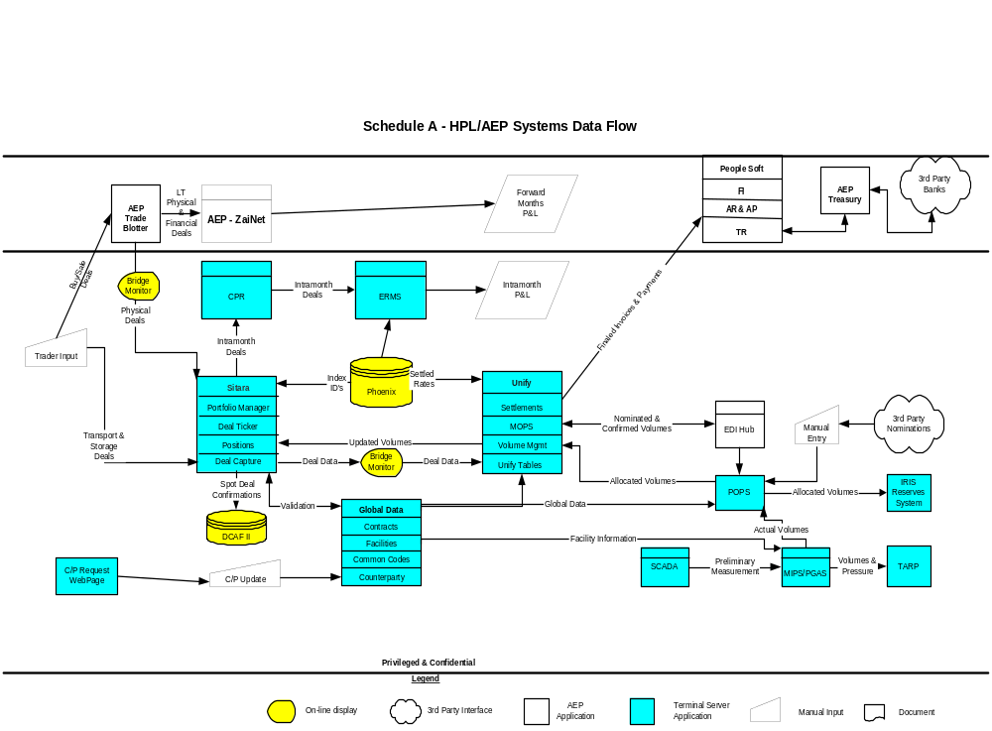

Schedule A
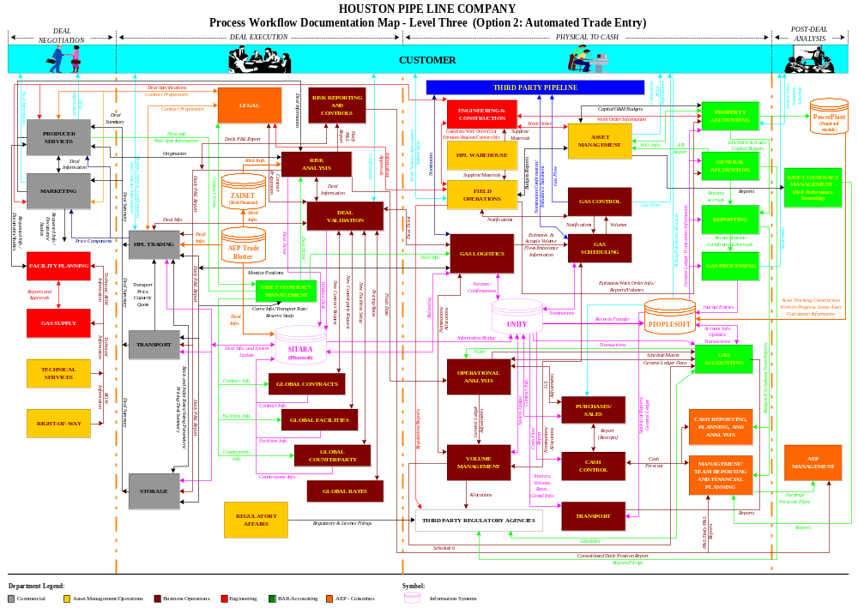

Schedule B

Schedule C

AEP/Enron Interfaces: Trade Information for Sitara

Background
AEP has entered into an agreement with Enron to purchase the Houston Pipeline (HPL). This part of the interface project will allow physical trades entered into AEP’s Trade Blotter application to be passed to the HPL Sitara application. This must be accomplished no later than June 1, 2001.

Change Management

Changes to this document will be handled via agreements between Enron and AEP. They will be documented and approved/rejected via Attachment C: Change Management Process Form.

Contacts
AEP
- Don Simpson, Wholesale IT Director (614-324-5060)
- Kurt Wissner, Wholesale IT Director (614-324-6847)
- Theresa Goldstein, Business Analyst (614-324-6924)
Enron
- Tom Yanowski (Sr. Director Enron Net Works; Tommy.J.Yanowski@enron.com; 713-853-6858)
- Jay Krishnaswamy (Manager, Sitara Development; jayant.krishnaswamy@enron.com; 713-853-5768)
- Dave Nommensen (Director, Sitara Development; dave.nommensen@enron.com; 713-853-6510)
- Russell Long 713-345-3754 (Enron Net Works)

Requirements

Enron
- Accept the AEP trade transactions sent via secured HTTP Post.
- Validate the transaction (in a process similar to what is used for Enron On-Line).
- Provide e-mail notification to AEP when transactions do not pass validation.
- Provide a GUI interface for AEP to view transactions that did not pass validation.
- Create an AEP portfolio in Sitara for AEP to view contract mismatch errors. This will also allow AEP users to match a trade to a contract in Sitara.
- There are existing deals in Sitara that periodically require re-forecasting of volumes. The re-forecasting is handling via the “base gas roll” process in Sitara. (Examples of these deals are “evergreen” and long-term.) When these rolls occur in Sitara, a separate file should be generated that contains information on the AEP trade involved as well as the volumes rolled (see Attachment B – Sitara Base Load Roll Data). A process will be created to allow AEP to view the file and download the information in it to an Excel spreadsheet.

AEP
1) Generate physical transactions from the trade capture application (Trade Blotter).
2) Map counterparty id, pipe code, trading zone, index id and facility number in the transactions to Enron’s values.
3) Send the transactions to Enron via HTTP Post.

Deliverables and Due Dates

Deliverable | Responsible Party | Due Date
AEP trade information file specifications (see Attachment A) | Enron | 3/19/01
Sitara Base Roll Table specifications (see Attachment B) | AEP | 3/19/01
Web server information for secured HTTP Post | Enron | 3/23/01
Information for mapping to pipe codes, trading zone codes, facility numbers and counterparties | Enron | 3/23/01
Initial trade information test file | AEP | 4/09/01
Counterparty confirmation information | Enron | 4/12/01
Process to view and extract Sitara base roll data – test version | Enron | 4/13/01
Sitara error transaction test GUI available | Enron | 4/16/01
Trade information test files | AEP | From 4/16/01
Sitara test system available to HPL traders | Enron | From 4/23/01
Trade information production files | AEP | From 6/1/01
Sitara AEP portfolio available in production | Enron | From 6/1/01
Process to view and extract Sitara base roll data – production version | Enron | From 6/1/01

Attachment A – AEP Trade Transaction

The following is structured as a row in an Oracle table would be presented. It also represents the information that will be sent in the packet via the secured HTTP Post method.

Seq Nbr | Proposed Enron Name | Field Attributes | Notes | AEP Trade Blotter Field Name
1 | RECORD_TYPE_FLAG | 1 character | Value ‘N’ (new), ‘U’ (update), ‘D’ (delete). Indicates if this is a new trade, an update to an existing trade or a request to delete a trade.  Calculated by IFW
2 | AEP_TRADE_NUM | Varchar2(20) | Saved in a separate Sitara field to allow later retrieval | Dealid
3 | BUY_SELL_FLAG | Varchar2(1) | ‘B’ for buy, ‘S’ for sell | PurchaseorSale
4 | AEP_COUNTERPARTY_ID* |  | Enron’s counterparty_id which must exist in GCP_GLOBAL_CP | Short name (10 characters) used in Trade Blotter
5 | DELIVERY_VOL_AMT | Number(38,2) | Value must always be positive for Sitara | Quantity
6 | END_DATE | Date. Format YYYYMMDD | From AEP Oracle database. End date of flow. Do not include time value | Enddate
7 | FIRMNESS_TYPE_CD | Varchar2(10) | “F” for firm, “I” for interruptible | ServiceLevel
8 | FREQUENCY_CD | Varchar2(40) | “mo” for monthly, “”d” for daily | StdHrlyPatternId
9 | PIPE_CD*% | Varchar2(4) | Enron’s PIPE_CD which must exist in GFD_PIPELINES | 1st part of location mapped to Enron’s location
10 | TRADING_ZONE*% | Varchar2(10) | Enron’s TRADING_ZONE_CD which must exist in GFD_TRADING_ZONES | 2nd part of location mapped to Enron’s location
11 | FACILITY_NO*% | Number(6) | Enron’s FACILITY_NO which must exist in GFD_FACILITIES. Optional and may be NULL | 3rd part of location mapped to Enron’s location.
12 | START_DATE | Date. Format YYYYMMDD | From AEP Oracle database. Start date of flow. Do not include time value | Startdate

 | Proposed Enron Name | Field Attributes | Notes | AEP Trade Blotter Field Name
13 | TRADER_ID* | Number(9) | Enron’s contact_id which must exist in GCP_GLOBAL_CP | Traderid
14 | BOOK* | Varchar2(10) | Mapped by AEP (to Enron’s book value in Global Data table) | Bookid
15 | RATE_CD | Varchar2(10) | Calculated by AEP. “IndexRate” or “FixedRate”
16 | PRICE | Number(11,6) | Either fixed price (positive) or offset to Index (positive or negative)  ???How do we indicate it is offset to Index? | Price
17 | INDEX_ID | Number(9) | Index Id which must be a valid RateServer handle | IndexId
18 | AEP_BROKER_ID* | NUMBER(9) | Mapped by AEP (BrokerId is in AEP Counterparty table. Brokers are also in Global Data counterparty table) | Brokerid
19 | AEP_BROKER_FEE* | Number(11,2) | NULLABLE. | Brokerfee
20 | COMMENTS | Varchar2(64) | Sitara supports multiple comment lines. This will be an optional comment and is visible in the Sitara deal display | Comments

*indicates field AEP must map
% Mapped by AEP to Enron’s pipe code, trading zone code and facility number

Attachment B – Sitara Base Load Roll Data

Proposed Enron Name | Field Attributes | Notes
AEP_TRADE_NUM | Varchar2(10)
PIPE_CD | Varchar2(4)
TRADING_ZONE | Varchar2(10)
FACILITY_NO | Number(6)
START_DATE | Date
END_DATE | Date
VOLUME | Number(38,2)

Schedule D

AEP/Enron Interfaces: Unify Invoice Information

Background
AEP has entered into an agreement with Enron to purchase the Houston Pipeline (HPL). As part of the agreement, Enron has granted a time limited right-to-use for the systems that are used by HPL. The right-to-use expires in 18 months; AEP was given some incentives to shorten the time frame and every effort to do so should be made.
The first part of the project will involve sending invoice data from the HPL Unify database to AEP. AEP will use this data to create transactions for their PeopleSoft system. The interface to provide the data must be ready to be used on June 1, 2001.

Change Management

Changes to this document will be handled via agreements between Enron and AEP. They will be documented and approved/rejected via Attachment B: Change Management Process Form.

Contacts
AEP
- Don Simpson, Wholesale IT Director (614-324-5060)
- Kurt Wissner, Wholesale IT Director (614-324-6847)
- Theresa Goldstein, Business Analyst (614-324-6924)

Enron
- Tom Yanowski (Sr. Director Enron Net Works; 713-853-6858)
- Chris Schomer (Manager, Technology – Unify; 713-853-9020)

Requirements

ENRON
- Create new reporting GUI in Unify to allow the extract of trading and marketing and pipeline operations deal transactions from the Unify database for HPL.
- AEP Accounting User will access the new reporting GUI to select filtering options (entity, accounting period, delivery period, counter party). Accounting period will be the only required field.
- Process behind the GUI will produce a CSV file of finalized invoice data (A/R land A/P transactions) that meet the parameters chosen in a)
- Process behind the GUI will FTP the file produced to a designated AEP server. Should no information be found that matches the parameters, an empty file should be sent to AEP.

AEP
1) Determine the data needed from Enron and communicate the layout of the file records to be returned from Unify.
2) Supply Enron with FTP server information (IP address, id and password). This is the server that Enron will send FTP transactions to for testing and production.

Deliverables and Due Dates

Deliverable | Responsible Party | Due Date
File specifications (see Attachment A) | AEP | 3/19/01
FTP server information | AEP | 3/23/01
Initial Unify test file | Enron | 3/23/01
FTP server available | AEP | 3/30/01
Unify test request screen available | Enron | 3/30/01
Unify test files (available on demand by AEP) | Enron | From 3/30/01
Unify production request screen available | Enron | From 6/1/01
Unify production files | Enron | From 6/1/01

Flow Diagram

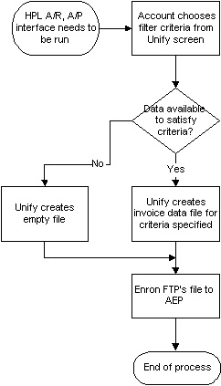

Use Cases

1. UC10: Request HPL A/R, A/P Data

Summary | This use case describes the activities of an A/R or A/P accountant when requesting relevant data from the HPL Unify system.
Description | The interface between the HPL Unify system and PeopleSoft begins with the request for data from the Unify system. The requesting accountant will choose from filter criteria presented on a screen.
Actors | Accountant, Unify System, FTP Server
Preconditions | Accountant must be logged into the Enron Unify system
Postconditions | Success: Accountant submits request to extract data using criteria selected  Failure: Accountant not able to submit request to extract data

List of Scenarios
  - Normal scenario: Accountant requests data
    - Accountant will choose from filter criteria and submit a request for data meeting the criteria selected.
  - Second scenario: Accountant begins to request data but does not complete the request (cancel scenario)
    - Accountant begins to choose or completely chooses from filter criteria, but decided to cancel request

Scenarios
2.1. Normal scenario:
    - Accountant chooses from among the following filters:
      - Entity
        - Choices are: HPL Marketing Co., HPL (pipeline), All
        - Default is All
      - Accounting period
        - This is a required field
        - Default is current month/year
      - Delivery period
        - This is an optional choice
        - Default is current month/year
      - Counter party
        - Choices will include a listing of individual counter parties.
        - Default is all counter parties.
    - Unify system processes request for invoice data (A/P and A/R data).
    - Unify system FTP’s file to AEP server.
  - Second scenario:
    - Accountant follows process 2.1.1 above, but decides not to request the data
    - Accountant pushes the Cancel button

Assumptions, Notes, Issues
3.1. Assumptions
3.1.1. Accountant knows how to log into the request system
3.1.2. Accountant will only want finalized data
3.2. Notes
3.3. Issues

Sample Screen Shot

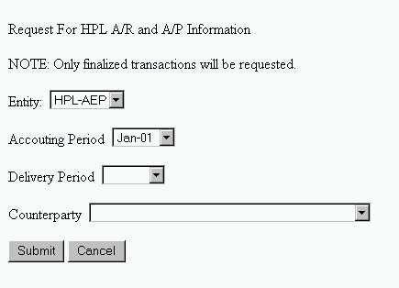

Attachment A – Unify Data File & Extract Logic

When requested via a Unify GUI, the Unify system will FTP to AEP a file of summarized invoice data (A/R and A/P data). The file will also include a Header and Trailer record to be used by AEP for verification purposes.

Header Record:

Field name | Field attributes | Field edits | Notes
(constant) |  |  | Value “Header”
Accounting Period |  |  | Period chosen by the Accountant in the Unify request GUI
Entity |  |  | Entity value chosen by the Accountant in the Unify request GUI
Counterparty |  |  | Counterparty value chosen by the Accountant in the Unify request GUI
Delivery Period |  |  | Delivery Period value chosen by the Accountant in the Unify request GUI

Trailer Record:

Field name | Field attributes | Field edits | Notes
(constant) |  |  | Value “Trailer”
Number of A/R records |  |  | Total number of A/R records sent
A/R Book_Amount total |  |  | Total of all Book_Amount fields for all A/R records
Number of A/P records |  |  | Total number of A/P records sent
A/P Book_Amount total |  |  | Total of all Book_Amount fields for all A/P records

Detail Record:

Unify Field name | Field attributes | Field edits | Notes
Entity name
Entity id
Statement_number | 16 characters |  | Invoice number
Invoice date | 8 characters, YYYYMMDD format
Invoice due date | 8 characters, YYYYMMDD format
AR_AP_Indicator | 2 characters | Valid values: ‘AP’ or ‘AR’
Book_Amount | 15 digits in total length with 2 decimal places to the right
Counterparty_id
Counterparty_name
Detail_type | 2 characters | Valid values: ‘SA’, ‘SP’, ‘SV’, ‘SI’
Payment_method |  | Valid values: ‘check’, ‘ACH’, ‘wire’

Other extraction logic:

- Input parameters: entity, accounting period, delivery period, counter party. NOTE: accounting period will be a required parameter. Other parameters may or may not be provided by AEP.
- Only finalized invoices will be considered when processing the criteria supplied by the AEP accountant.
- A file will always be returned to AEP, even if no invoice data meets the criteria specified by the AEP accountant. In the event that no data matches the criteria, an empty file should be returned. When data is returned, it will be in an ASCII CSV format.
- The invoice data will be summarized; that is, detail line items for an invoice will be summarized into one record per invoice. The Book_amount field should contain the total amount of the summarized line items. An indicator as to whether or not the resulting summarized transaction is for A/P or A/R will be provided.
- Any record meeting the criteria should be returned. If, for example, only A/R records are found meeting the criteria, and no A/P records are found, the A/R records should be returned..

